[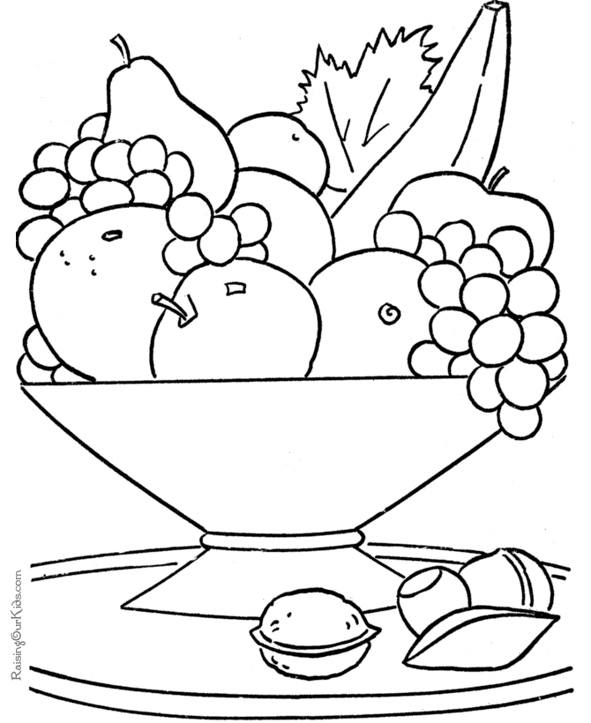](https://www.google.co.uk/url?sa=i&rct=j&q=&esrc=s&source=images&cd=&cad=rja&uact=8&ved=2ahUKEwjc2-PPos_gAhWrzoUKHcYeANEQjRx6BAgBEAU&url=https%3A%2F%2Fnl.pinterest.com%2Fpin%2F502081058433265324%2F&psig=AOvVaw3GAN_4qpzS49zwCRKhzjJG&ust=1550922364790503)****

**Blue Bell Little Ones**

**Snack pot £2.00**

Homemade humus with cucumber and carrot sticks and crisp bread

**Mains  
Cheeseburger**

Homemade cheeseburger in a brioche bun gem lettuce and fries (GFP)

**Plaice goujons**

Fresh plaice goujons served with hand cut chips

and garden peas

**Tomato and mozzarella pasta**

pasta with spinach, fresh tomato and mozzarella (v)

**Breaded Scampi**

Scampi and hand cut chips with garden peas

**Sweet and sour stir-fry**

Chicken or vegetable stir fry, basmati rice and homemade sweet and sour sauce (DF) (GF)

**Picnic plate**

Cheese sandwich, Banana, cucumber and carrot sticks, homemade hummus, raisin pot. (V) (GFP)

**2 courses for £7.50**

**Desserts**

**Chocolate brownie**

Homemade brownie with vanilla ice cream and chocolate soil

**Sticky toffee pudding**

Sticky toffee sponge, caramel sauce and honeycomb ice cream

**Scoop of ice cream**

Strawberry, Chocolate, Vanilla or

Mango(df)

[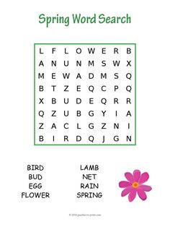](https://www.google.co.uk/url?sa=i&rct=j&q=&esrc=s&source=images&cd=&cad=rja&uact=8&ved=2ahUKEwiKt8HDoc_gAhWCx4UKHZR_DOsQjRx6BAgBEAU&url=https%3A%2F%2Fwww.pinterest.com%2Fpin%2F428475352017673029%2F&psig=AOvVaw3LQUZbhqMN71UgPxpvIDY7&ust=1550922173219772)

**Children’s drinks**

Water Free ~ Squash 50p ~ Juices £1.50 ~ Milk £1.00 ~

J20 £2.50

Riddle Me This:

1. What has to be broken before you can use it?
2. Which letter of the alphabet has the most water?
3. What word is spelled wrong in every dictionary?

(GFP)Gluten free possible (GF) Gluten free (V)Vegetarian